A

REPORT

ON

PARENT’S TEACHER’S MEETING 2024

SRSSION 2024-2025

DEPARTMENT OF PHILOSOPHY

Rabindra Mahavidyalaya

Champadanga, Hooghly

Theme: PARENT’S TEACHER’S MEETING 2024

Venue: Rabindra Mahavidyalaya, champadanga

Department of Philosophy,

room no. 69

Date: 31st December 2024

Organizer: Department of Philosophy

Objectives:
- To Review grades, attendance, and progress in individual subjects. (Discuss academic performance).
- To gain insights into a student's home environment and parents to get a clearer picture of their student's college life.
- To helping our son/daughter develop their social skills and feel confident in your classroom, you have been exactly what we were looking for,"

Notice
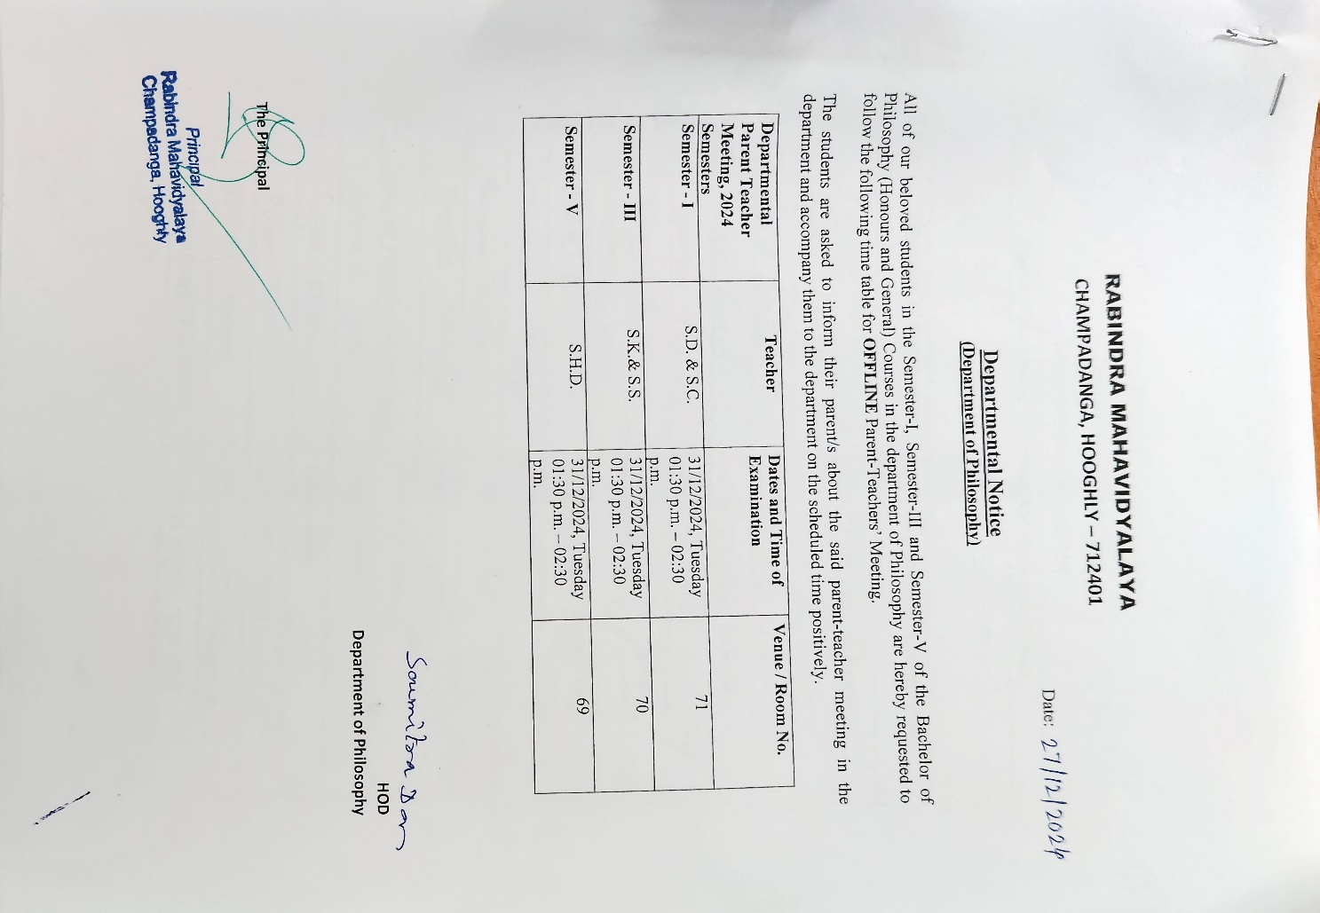

summary

On 31st December, 2024 the department of philosophy organized a parent’s teachers meeting. in the future. a formal opportunity for parents and faculty to discuss a student's academic and personal progress, attendance, and overall well-being. Faculty shared detailed feedback on performance in internal tests, assignments, and projects. Underperforming students were specifically identified for additional support. The importance of maintaining a minimum attendance (e.g., 75%) and regularity was emphasized. Reasons for poor attendance were discussed. Discussions included career aspirations, internship opportunities, and the necessity of completing activity points for overall development. Teachers and parents discussed students' social interactions, behavior in class, motivation, and any personal issues affecting their studies, with a focus on finding solutions.
The Parent-Teacher Meeting was a productive and successful endeavor that strengthened the relationship between the college and parents. The active participation and valuable feedback from parents underscored the shared commitment to the students' academic excellence and holistic development. The meeting concluded on a positive note, with a mutual understanding that continued cooperation is essential for student success.

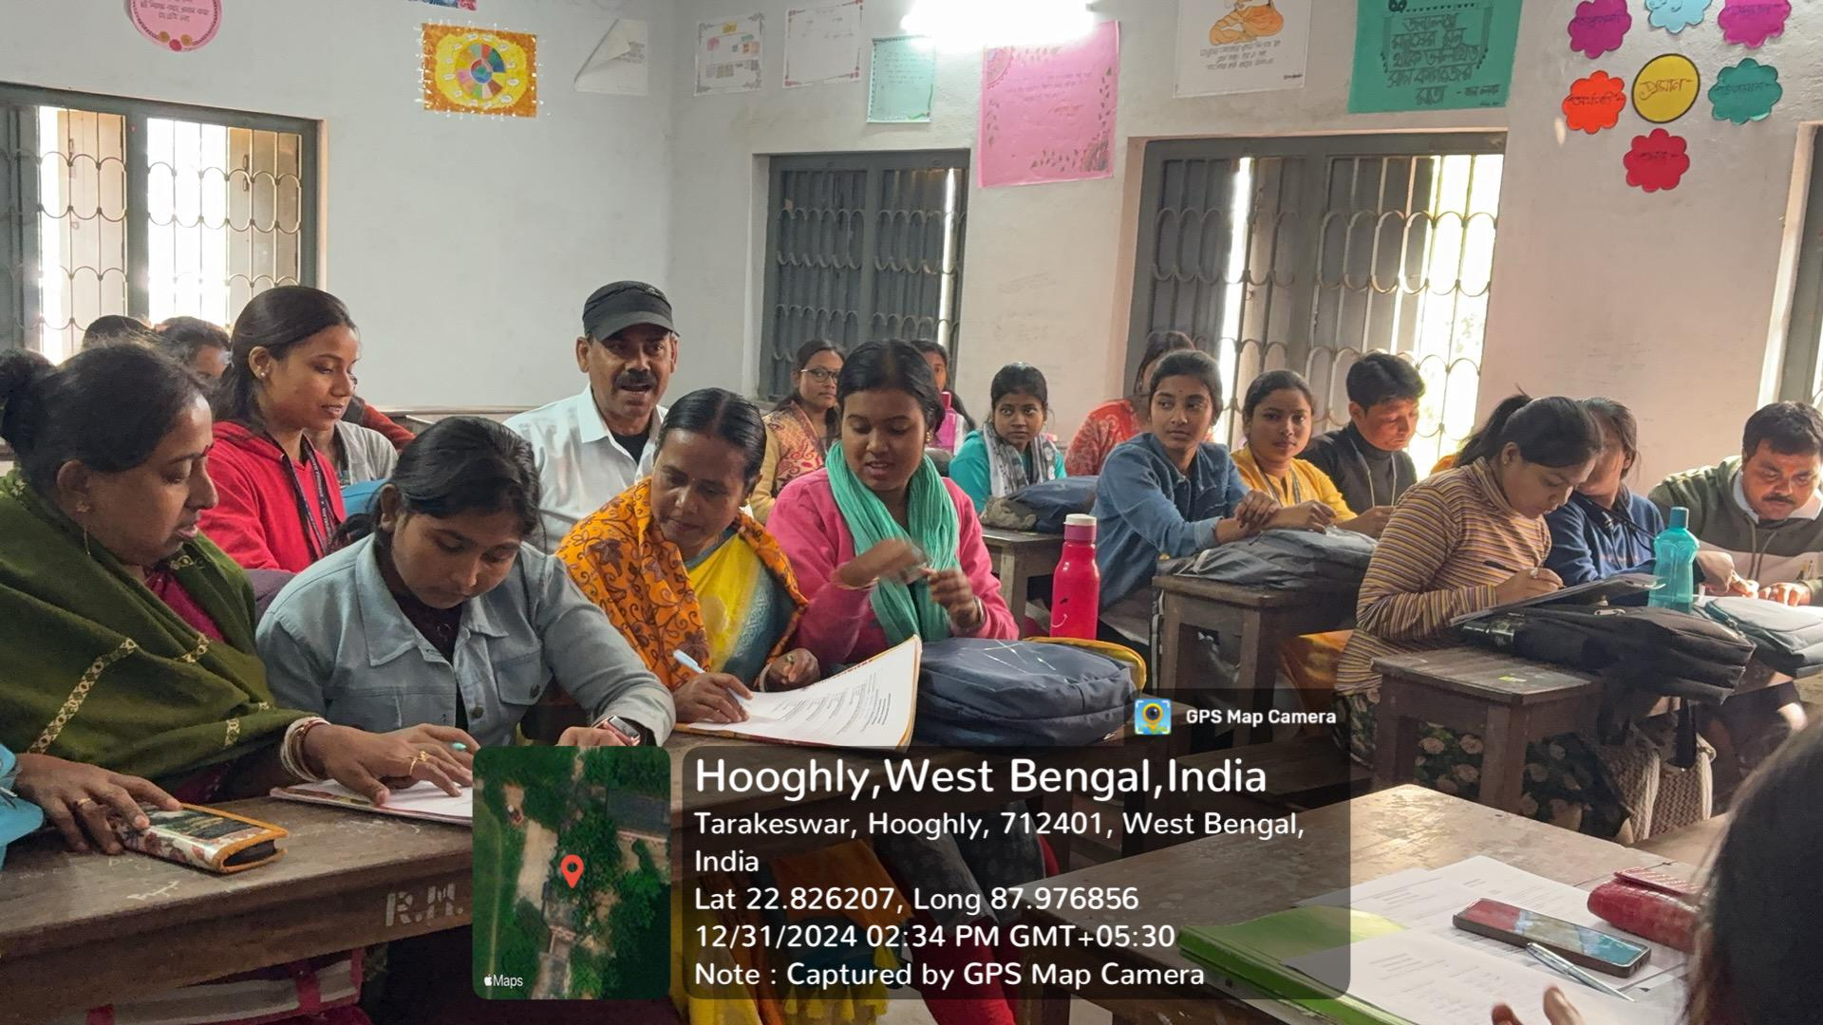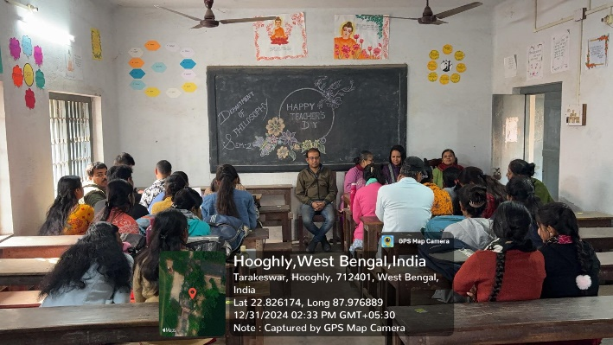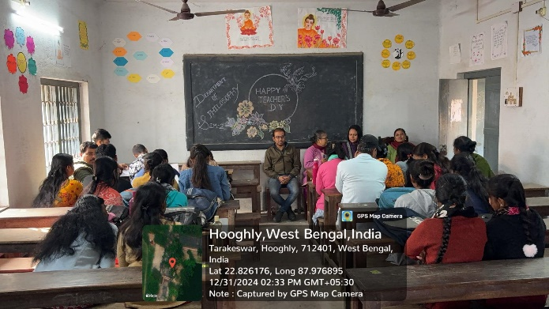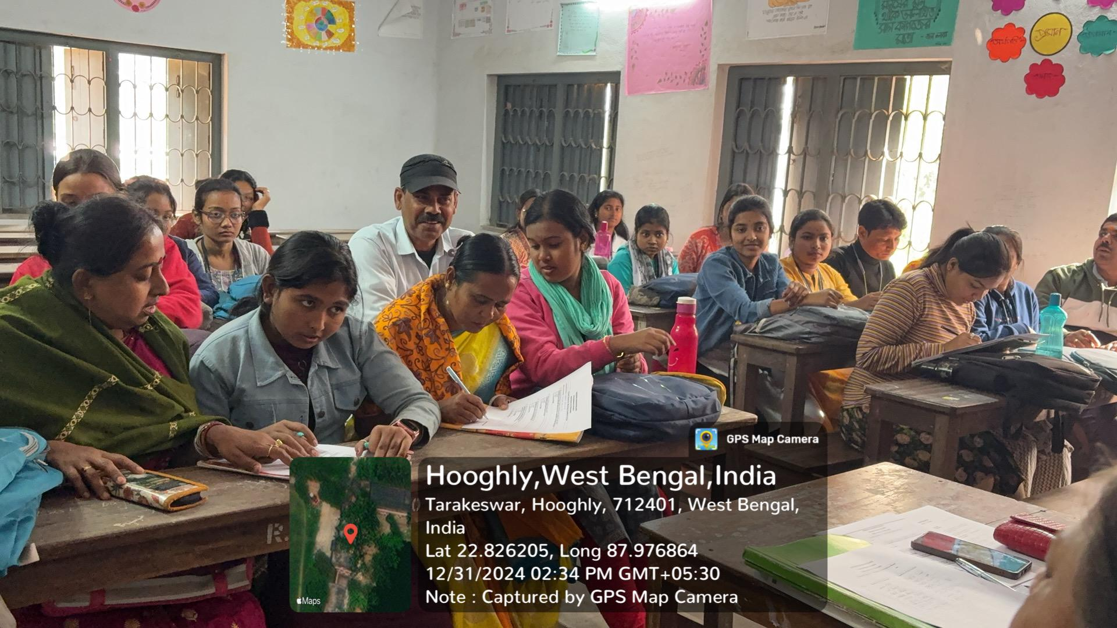

Attendence sheet :
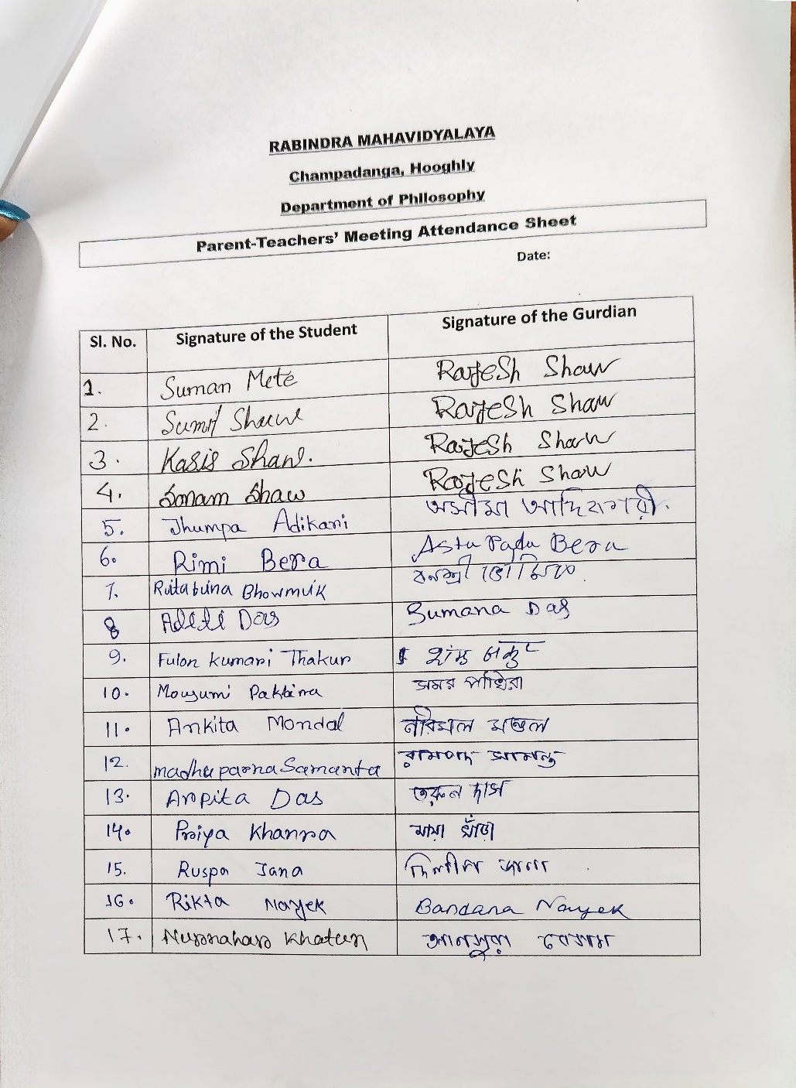

Attendance: 34
Male: 6
Female:28

Feedback from Parents:
- 90% felt satisfactory
- 70 percent wished to occur the meeting more than once every year.
- Some parents want more interaction one by one student by the teacher.

Some feedback from parents:
- "Thank you for taking the time to discuss my child's progress. We appreciate your insights and the care you show for their academic and personal growth,"
- "By helping our son/daughter develop their social skills and feel confident in your classroom, you have been exactly what we were looking for,"
- "The teachers are very cooperative and always try to help the parents along with the students,"

